GRADIENT OF A LINE
Pearson Edexcel - Thursday 4 June 2020 - Paper 2 (Calculator) Foundation Tier

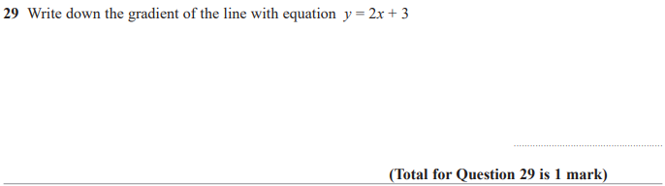

Pearson Edexcel - Thursday 8 November 2018 - Paper 2 (Calculator) Foundation Tier

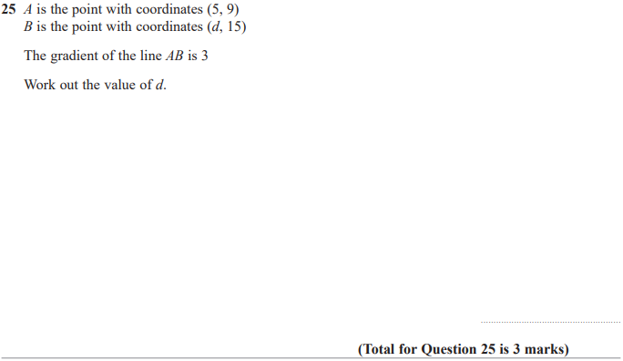

OCR Thursday 07 November 2019- Morning (Non-Calculator) Foundation Tier
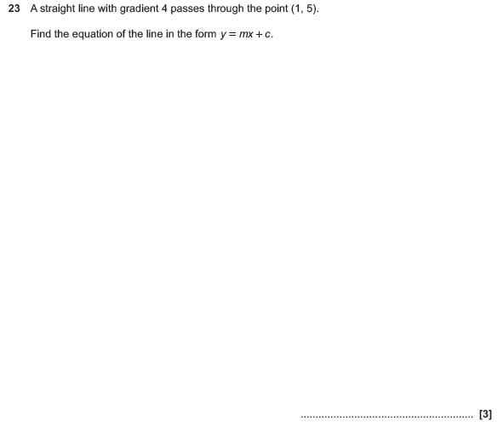

OCR Wednesday 8 November 2017– Morning (Calculator) Foundation Tier

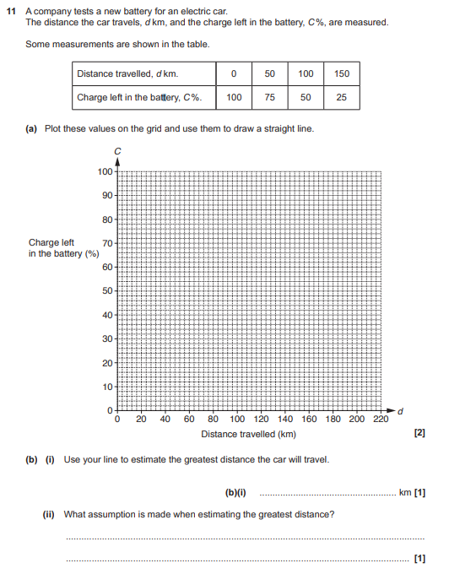

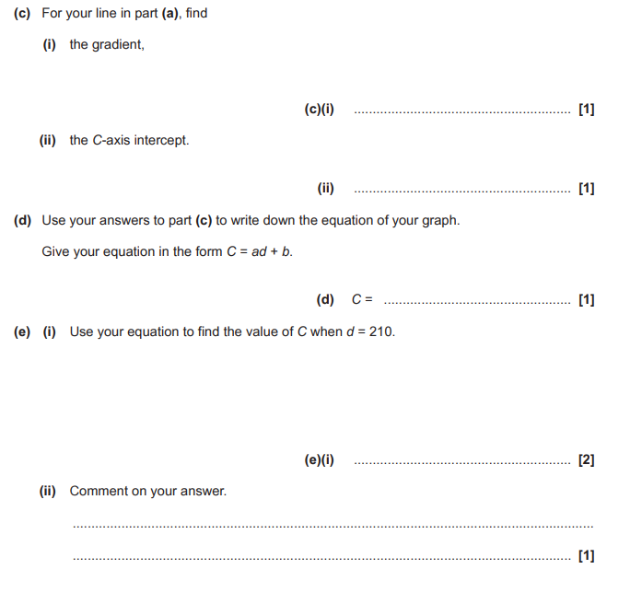

AQA Thursday 4 June 2020 – Morning (Calculator) Foundation Tier

